Forecasting and Analyzing the Trend of COVID-19 Cases in India
Vedant Manohar Pandya¹ , Shivanshu Surendra Shrivastava² , Akash Rajesh Singh³ , Anand Digambar Khandare⁴

¹Computer Engineering, TCET, Mumbai, Maharashtra, India
²Computer Engineering, TCET, Mumbai, Maharashtra, India
³Computer Engineering, TCET, Mumbai, Maharashtra, India
⁴Computer Engineering, TCET, Mumbai, Maharashtra, India

lncs@springer.com
Abstract. The abstract should summarize the contents of the paper in short terms, i.e. 150-250 worEver since WHO declared COVID-19 to be a pandemic, the entire world has been reeling under its deadly consequences. Hence, it is quintessential for Governments all around the world, to be able to predict the trajectory of this novel virus. Tools like AI and Data Science, have been since used extensively by leading universities, to try to map out the COVID-19 curve. Researchers and data scientists worldwide, have analysed various statistics of COVID-19, and have made their predictions. Many Research Institutions have used these statistics to visualize the COVID-19 data, and have derived conclusions on how each Country has fought against the Virus. In our paper, we have tried to map the COVID-19 curve of India, similarly, using real time statistics published by MoHFW and complex mathematical models, which are often used in epidemiology, which can be used by Government of India, to formulate better strategies to contain its spread. In our paper, we have used non-linear regression to fit the COVID-19 Indian Statistics on four different models, viz. Gompertz Model, Logistic Model and Bertalanffy Model, to predict the total number of cases. This model is further used to plot the curve of Total Cases in India, which can be used for identifying the COVID-19 trend in India. We have used Regression Co-efficient (R2) for measuring the performance of our models. R2 Coefficient for Gompertz and Bertalanffy is mostly in the range of 0.77-0.78, whereas for Logistic Model, it is in range of 0.76-0.77. Comparison of the predictions before and after each phase of Unlock was tabulated, to portray and analyse the effects of each Unlock.
ds.
Keywords: First Keyword, Second Keyword, Third Keyword.
- Introduction
esults. Results section here, then new line.
Discussion. Discussion section here.

Having been originated in China on 31st December, COVID-19, has now affected more than 20 Million People, worldwide, with more than 730,000 deaths. COVID-19 was declared to be a global pandemic by WHO on 11th March 2020 [1]. Ever since then, the number of cases reported have been increasing daily. In the initial phase of the outbreak, Europe was the most affected continent, with countries like Iran and Spain, being affected the most and also experiencing a very high death toll. However, in the later phase of pandemic, Continental US started emerging to be a hotspot. As of August 2020, USA accounts for approximately a fourth of total cases ever registered, having a caseload of 5 Million cases.
However, some of these countries are now facing a second wave of COVID Cases. Hence, it is essential to construct models capable of predicting the trend of the Curve, to help Governments around the world to create better strategies to combat this pandemic [2].
India which reported it’s first COVID case on 30th January 2020 in the state of Kerala where a student returned from the Wuhan tested positive for 2019-Ncov [3]. However after getting a certain surge in the number of affected patients in the early start of March, India reacted to COVID-19 Pandemic, with one of the world’s strictest lockdown, starting from 25st March 2020 [4]. From March to August 2020, India imposed 4 Lockdowns, to curb the growth of the pandemic. To kickstart the economy, India then started unlocking from 1st June 2020, in multiple phases. As of August 2020, India is under the 3rd Phase of Unlock, known as Unlock 3.0. In the initial phase of outbreak, India fared better than other countries in the world, where number of COVID cases were relatively less in all states of India other than Maharashtra where Maharashtra was experiencing daily count of COVID cases of approximately 4000 -5000. In months until June, India had recorded relatively less cases, as compared to other countries like Russia, USA, UK and France. However, after the relaxation of lockdown, India has seen record surges in cases, taking its caseload from 150,000 in the month of June to more than 2 Million, as of 10th August, 2020. At the current period of time ,India stands 3rd in the highest number of COVID cases around the world, whereas it stands 1st in the highest number of COVID cases being reported per day in any part of the world. In the early phase where Maharashtra was the highest contributor of COVID cases, in addition to that the other densely populated states of India has also experienced a great surge in their tally. AS of 10th August 2020 , the states like Andhra Pradesh, Tamil Nadu, Karnataka and Uttar Pradesh are experiencing a daily toll of cases between 4000-9000 and confirmed cases has surpassed the 1 lakh mark. This huge surge in cases has been attributed to a number of factors like increase in testing, unlocking of the country, etc. In the first two weeks of August, India has been recording more than 50,000 cases daily, having recorded the highest number of cases in the first two weeks. To create better strategies and combat the virus much more effectively, it is necessary for the Government, to be able to comprehend the trend of COVID.
In this paper, various epidemiological models like Gompertz, Logistic and Bertalanffy model, have been used to predict the COVID-19 curve of India [5]. Along with these predictions, the effect of each unlock on these models was also visualised. These predictions can be used by Government Officials to identify the current situation of COVID-19 Outbreak in India.

- Materials & Methods
Traditionally epidemic prediction models consist of differential equations models, time series models, Internet based infectious disease prediction model and several Machine Learning models.
  - Differential equations models
Differential Equations are used to reflect the dynamic characteristics of infectious diseases as per population growth, occurrence of disease and its rate of transmission within the mass.
The widely studied models re SI models, SIS model, SIR model and SEIR model etc where S (Susceptible), E(Exposed), I (Infected) and R (Remove) [6].
The important parameter is that it considers the overall population of the system as constant which isn’t entirely correct there is gradual change in it.
  - Time series prediction model
These are based on using previous values of time series and then predicting future values.
As Infectious disease spread exponentially the best known time series model are ARIMA ( Auto regressive Integrated Moving Average model) Model , Grey Model (GM), Markov chain method (MC) [7].
  - Internet-based infectious disease prediction model
Use of internet for infectious disease analysis has begun to rise since mid 1990s [8]. In early stages , traditional web search was the main source for data required to carry out the research and carry out appropriate task in our case warning people before hand [9]. However with the development in various technology and boom of internet the amount and rate at which data is generated is huge, and if a particular topic or scenario is occurring then the search or data stream would be surrounding to that topic only and hence it can be utilized to perform analysis [10].
Theoretically it seems one of the more correct and appropriate way of carrying out the prediction [11]. Also it has proven its worth during 2004-2009 with official surveillance data of flu and the data generated from model [12].
But in practice it was found that the spatial resolution and the accuracy needs to be further improved also , Internet based models cannot replace traditional models they can act as an extension for the same [13].

  - Machine Learning models for prediction of Infectious Disease
Generally ,machine learning is to learn more useful information from huge amount of existing data for a specific problem .
Machine learning spans across various fields viz. medicine, computer science, statistics, engineering technology, psychology etc. [14].
When faced with complex data relations, the traditional statistical method is not such effective, which may not receive accurate results as the neural network [15].
However, the highly nonlinear and complex problems to be analysed in the early prediction model of infectious diseases based on machine learning usually lead to local minima and global minima, leading to some limitations of the machine learning model.
- Models
Machine Learning Models can be used to fit curves on time-series data, using non linear regression methods. As COVID-19 is an infectious disease, standard Epidemiological models can be used to plot its curve. In this paper, to avoid overfitting, relatively simple mathematical models like Gompertz Model, Logistic Model and Bertalanffy Model were used to carry out the predictions. For the statistical Analysis of COVID-19 in India, the “COVID-19 India” dataset available on Kaggle was utilized [16]. This dataset provides daily information about total number of Confirmed Cases, Cured Cases and Fatalities, state wise.

  - Logistic Model
Logistic Model is extensively used in Epidemiology for Statistical Analysis [17]. Logistic analysis is performed to establish the relation between a dependent variable and a number of independent factors. In case of epidemiology, number of cases acts as the dependent variable and the number of days since the first reported case, acts as the independent variable. Logistic Model uses the following Formula:
$$y \left(t\right)= \frac{a}{1+e^{b-ct}}$$

where $y(t)$ is the total number of cases reported, after t days
$a$ is the upper limit of the reported cases
$b,c$are fitting parameters

  - Gompertz Model
Gompertz Model is considered to be more realistic, and can explain the trends of outbreaks like COVID-19, better than Logistic Models[18]. Unlike Logistic Model, Gompertz Model are asymmetric, allowing them to represent a different growth dynamic. Gompertz Model uses following formula:

$$y \left(t\right)= ae^{-b^{-ct}}$$
where $y(t)$ is the total number of cases reported, after t days
$a$ is the upper limit of the reported cases
$b,c$are fitting parameters

  - Bertalanffy Model

$$y \left(t\right)= {a(1-e^{-bt})}^{c}$$

where $y(t)$ is the total number of cases reported, after t days
$a$ is the upper limit of the reported cases
$b,c$are fitting parameters

  - Regression Co-efficient
In this paper, Regression Coefficient (R2) is used to analyse the performance of the acquired predictions. Regression Coefficient is defined by the following formula:
$$R^{2}=1- \frac{\sum{{(y-\hat{y})}^{2}}}{\sum{{( y-\overline{y})}^{2}}}$$
where $y$ is the actual number of confirmed cases
$\hat{y}$ is the predicted number of confirmed cases
$\overline{y}$ is the mean of actual number of confirmed cases
Using the minpack.lm package in R Studio, the values of a, b and c, are calculated using the Non Linear Regression Least Square Method. Using these parameters, the corresponding predictions for upto 400 days, have been plotted.
In order to study the effect of Unlock on the COVID-19 curve, predictions made on data before the unlock and after the unlock have also been recorded. Along with the graphs of Confirmed Cases, the predictions of Active cases, Recoveries and Fatalities have also been recorded.
- Results
  - Analysis
Confirmed Cases:

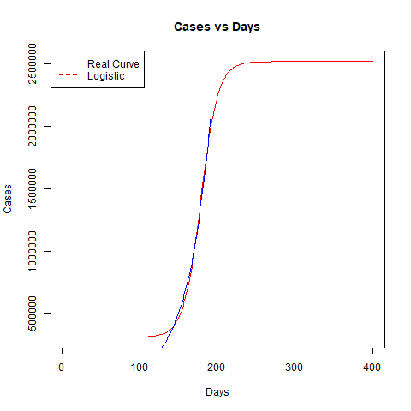
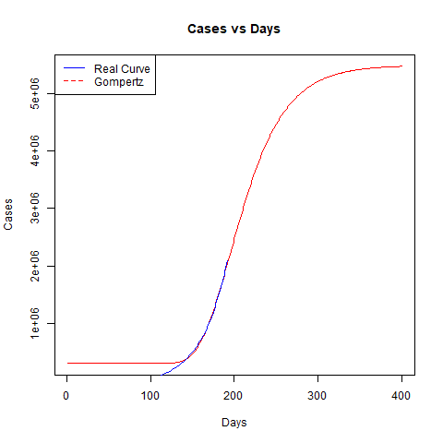

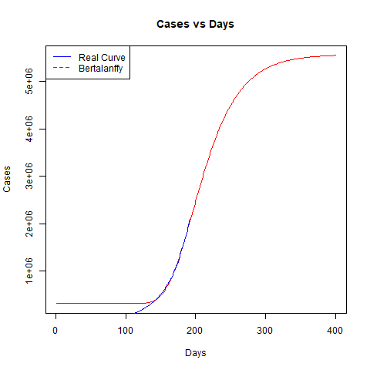

Figure 1: Total Number of Confirmed Cases
The graphs obtained after fitting the COVID-19 Confirmed Cases data until 10th August 2020, have been represented in Fig.1. According to the Gompertz Model, Logistic Model and von Bertalanffy Model, the upper limit of cases recorded in India are 5.48 M, 2.52 M and 5.67 M, respectively. Further analysis of the graphs shows that, Logistic Model predicts that India will attain the peak earlier than the predictions made by Bertalanffy and Gompertz Model. It should be noted that the predictions made by Bertalanffy and Gompertz Model are more than twice of the predictions made by Logistic.
Active Cases:
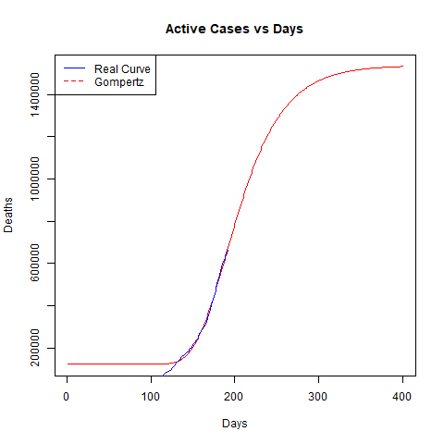
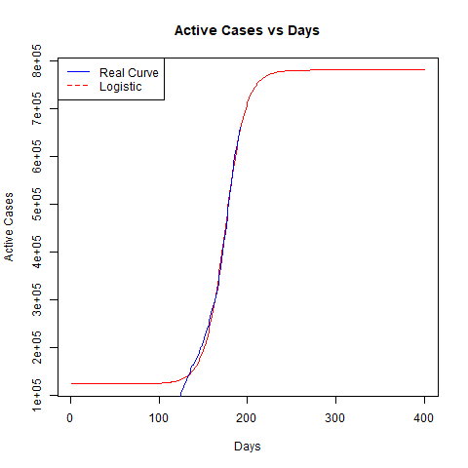

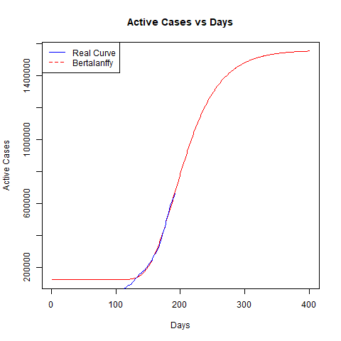

Figure 2: Total Number of Active Cases
According to Gompertz Model, Logistic Model and von Bertalanffy Model, in Fig. 2 the upper limit of the Active Cases recorded in India are 1.53 M, 760,000 and 1.56 Million, respectively. With a trend similar to that of Confirmed cases, it can be noted here as well, that like Confirmed Cases, the number of Active cases predicted by Gompertz and Bertalanffy Model are more than twice the amount of active cases predicted by Logistic Model.
Deaths:
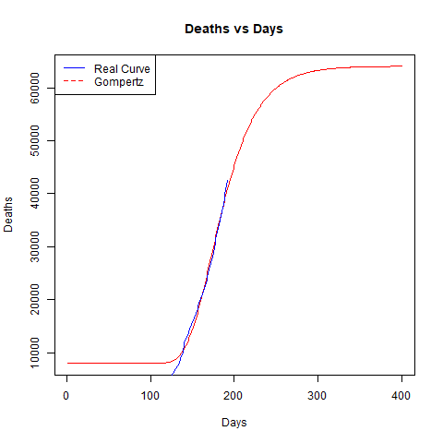
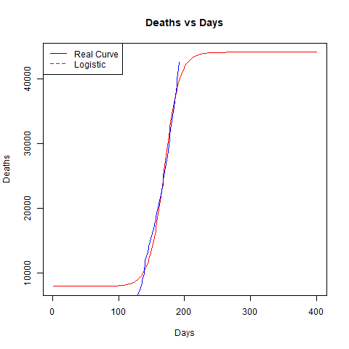

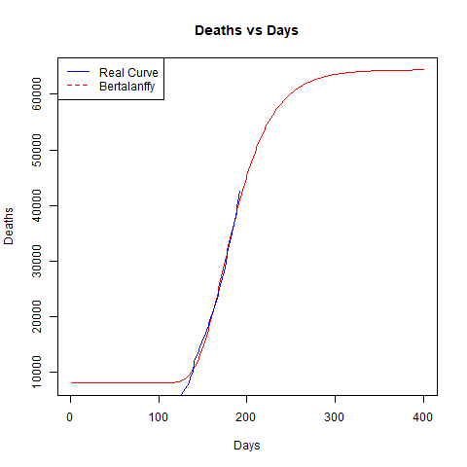

Figure 3: Total Number of Deaths

The upper limit of deaths was predicted to be 64,082, 44,066 and 64,427 by Gompertz, Logistic and Bertalanffy Models respectively, as portrayed in Fig.3. The trend of the deaths predicted is similar to that of Confirmed cases, with Gompertz and Bertalanffy predicting significantly higher number of fatalities as compared to Logistic.
Recoveries:
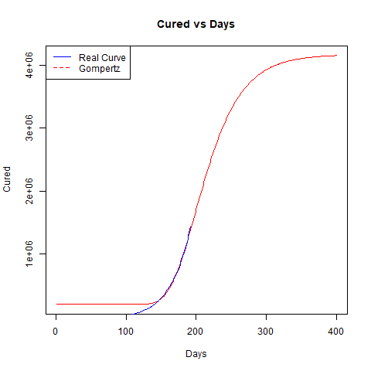
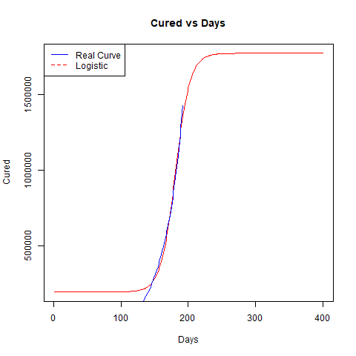

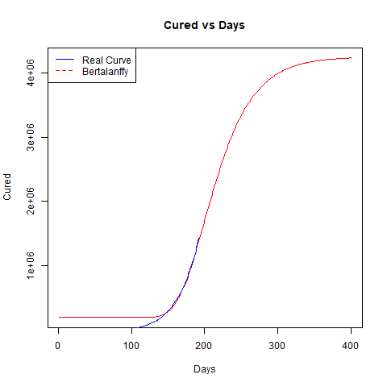

Figure 4: Total Number of Recoveries

As seen in Fig.4, Gompertz and Bertalanffy model, predicted the highest number of recoveries, with 4.17 M and 4.25 M Recoveries, respectively. Logistic Model, on the other hand, predicted the upper limit of recoveries to be 1.77 M. This huge difference in the number of recoveries can be attributed to the fact that the cases predicted by Gompertz and Bertalanffy model are significantly higher as compared to those compared by Logistic Model.

  - Comparative Analysis

Before and After Unlock 2:
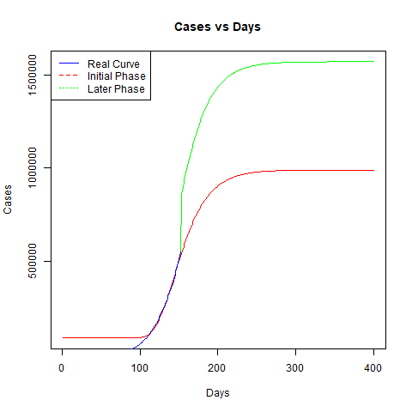
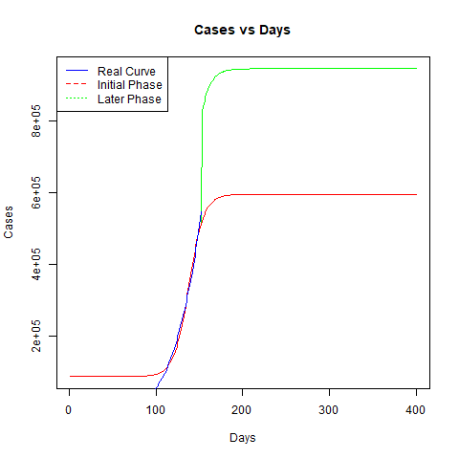

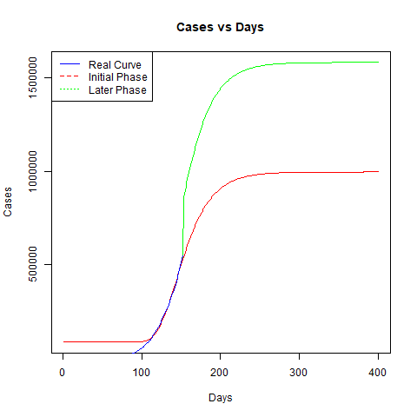

Figure 5: Predictions during initial and later phase of Unlock 1

Figure 5: Predictions during initial and later phase of Unlock 1

Comparing the predictions made by the models at the initial phase of Unlock 2 (1st July, 2020) and the predictions made by the models in the later Phase (15th July, 2020), it can be seen in Fig.5, that there was a huge surge in the number of cases, reported after Unlock 2. Due to this surge of new cases, the predictions made by the models, changed drastically. At the start of Unlock 2, Gompertz, Logistic and Bertalanffy predicted the upper limit of the cases to be 989,000, 596,000 and 996,000 respectively. However, at the later phase of Unlock 2, the predictions changed to 1.83M , 994,000 and 1.85M respectively.

Before and After Unlock 1:

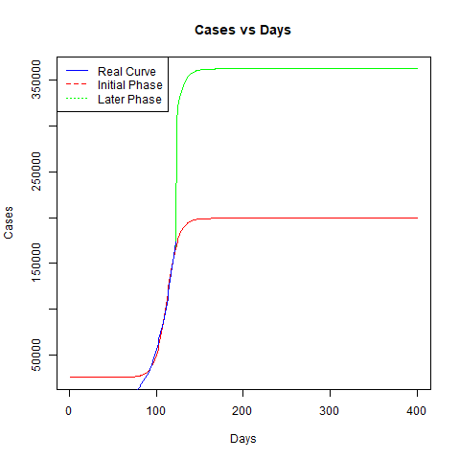
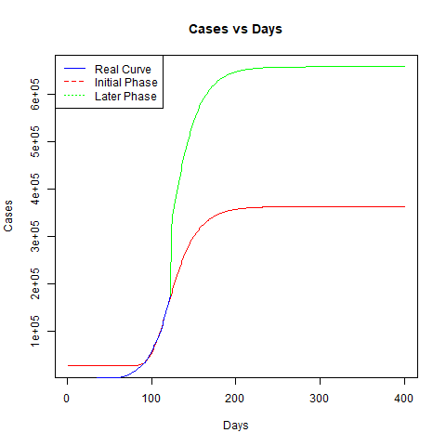

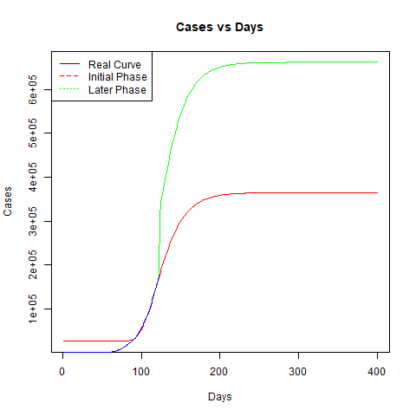

Figure 6: Predictions during initial and later phase of Unlock 2

Performing a similar analysis on Unlock 1 as seen in Fig.6, the predictions changed from 362,000, 199,00 and 364,000 at the start of Unlock 1 (1st June 2020) to 567,000, 341,000 and 569,000, during the later phase of Unlock 1 (15th June 2020).

Before and After Lockdown 4
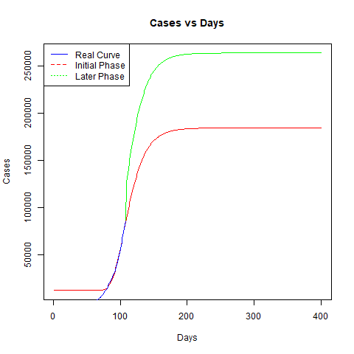
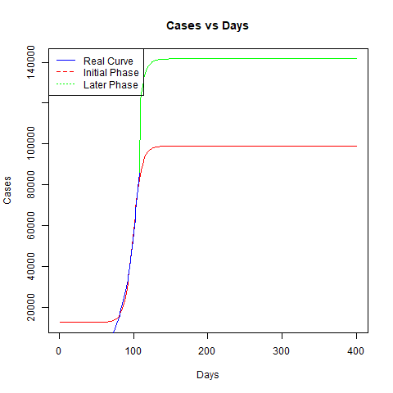

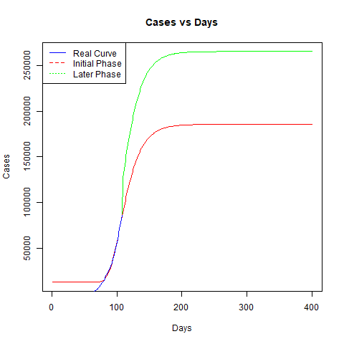

Figure 6: Predictions during initial and later phase of Unlock 2

It can be noted from Fig.7, at the start of Lockdown 4 (18th May, 2020) , each model predicted the upper limit of cases to be 184,000, 98,000 and 185,000. However, during the later phase (25th May, 2020), the predictions were increased to 259,000, 141,000 and 260,000.

- Discussion
  - Inference from Analysis
From Table 1, it can be seen that the Regression Co-efficient for fitting lies in range of 0.76 -0.84. It can also be concluded from the table, that out of the three models, Bertalanffy fits better, most of the time and Logistic fits the least. Hence, Bertalanffy and Gompertz model are much more suited to forecasting viral outbreaks, as compared to Logistic.
Table 1: Values of Fitting Parameters and R2

 | Model | A | B |  | c | R2
Confirmed Cases | Gompertz | 5484285 | 109067490.6 |  | 330381.017 | 0.78382682
Confirmed Cases | Logistic | 2520182 | 8507905.508 |  | 362216.445 | 0.78074852
Confirmed Cases | Bertalanffy | 5573275 | 330179.365 |  | 100000000 | 0.78384002
Active Cases | Gompertz | 1536924 | 28163323.35 |  | 128772.88 | 0.74933055
Active Cases | Logistic | 780700 | 2764636.505 |  | 139147.250 | 0.74719715
Active Cases | Bertalanffy | 1560547 | 128695.6299 |  | 26261193.6 | 0.74934108
Deaths | Gompertz | 64082 | 3836257.896 |  | 8367.48315 | 0.7425695
Deaths | Logistic | 44066 | 179721.9004 |  | 8993.91009 | 0.73714660
Deaths | Bertalanffy | 64427 | 8364.527194 |  | 3688807.64 | 0.74258473
Recoveries | Gompertz | 4174822 | 76699398.69 |  | 201455.061 | 0.79911449
Recoveries | Logistic | 1775125 | 5737719.381 |  | 223004.692 | 0.79546144
Recoveries | Bertalanffy | 4252726 |  | 201319.630 | 71855385.1 | 0.79913043

Confirmed Case:
The maximum upper limit of Confirmed cases reported in India, will be 5.67 Million, as predicted by the Bertalanffy Model. It can be interpreted that least number of cases reported by India will be 2.52 M, as predicted by the Logistic Model. The number of cases reported by Gompertz and Bertalanffy were found to be more than twice the number of cases reported by Logistic. This makes Logistic the best-case scenario, with India attending the peak, significantly before the peaks reported by Gompertz and Bertalanffy.

Active Cases:
The maximum number of Active Cases present in India, was found out to be 1.56 M, as predicted by Bertalanffy Model. Logistic Model predicts the upper limit of Active cases to be 760,000, which is also the least number of Active Cases, out of the predictions made by the three models. Active Cases follow a similar trend, as observed in Confirmed Cases, as Active Cases are dependent on the total number of cases.
Deaths:
According to the results, the highest count of fatalities recorded by India will be around 64,000, as predicted by the Bertalanffy model. The lower limit of deaths recorded is 44,000, as predicted by the Logistic Model. This low fatality figure, is in accordance with the low mortality of COVID-19 in India.
Recoveries:
Bertalanffy Model predicts the highest number of recoveries, at 4.25 M, whereas Logistic Model, which predicted the least number of cases, consequently predicted the lowest number of recoveries at 1.7 M. This high recovery figure, is in accordance with the high recovery rate of COVID-19 cases in India.

  - Inference from Comparative Analysis
The values of Regression Co-efficient (R2), the upper limit of number of cases (a) and the fitting parameters (b,c), have been listed in the Table 2.

Table 2: Fitting Parameter and R2 values during initial and later phases of Lockdown 4

Date | Model | a | b | c | R2
12-05-2020 | Gompertz | 146732 | 4587430 | 9849.291 | 0.790752
12-05-2020 | Logistic | 74902 | 265913.6 | 11683.31 | 0.786077
12-05-2020 | Bertalanffy | 148504 | 9839.586 | 4353631 | 0.790768
18-05-2020  (Lockdown 4) | Gompertz | 184247 | 8115588 | 13935.85 | 0.788806
18-05-2020  (Lockdown 4) | Logistic | 98970 | 382177 | 16429.21 | 0.785448
18-05-2020  (Lockdown 4) | Bertalanffy | 185543 | 13926.83 | 7816140 | 0.788814
25-05-2020 | Gompertz | 259059 | 11534514 | 20098.35 | 0.786517
25-05-2020 | Logistic | 141239 | 538464.8 | 23370.83 | 0.782742
25-05-2020 | Bertalanffy | 260804 | 20086.59 | 11120114 | 0.786526
India imposed 4 Lockdowns to curb the growth of COVID-19 and started loosening those restrictions, via 3 Unlocks, as of 10th August 2020.

Before and After Lockdown 4:
After the end of Lockdown 4, Gompertz Model witnessed an increase of 40.7%, Logistic Model witnessed an increase of 32% and Bertalanffy Model witnessed an increase of 40.5%, in the number of cases reported.

Table 3: Fitting Parameter and R2 values during initial and later phases of Unlock

Date | Model | a | b | c | R2
25-05-2020 | Gompertz | 259059 | 11534514 | 20098.35 | 0.786517
25-05-2020 | Logistic | 141239 | 538464.8 | 23370.83 | 0.782742
25-05-2020 | Bertalanffy | 260804 | 20086.59 | 11120114 | 0.786526
01-06-2020  (Unlock 1) | Gompertz | 362145 | 16116894 | 28302.71 | 0.785726
01-06-2020  (Unlock 1) | Logistic | 199137 | 751152.7 | 32588.23 | 0.782077
01-06-2020  (Unlock 1) | Bertalanffy | 364755 | 28286.28 | 15509340 | 0.785735
15-06-2020 | Gompertz | 567547 | 38194727 | 52215.99 | 0.781125
15-06-2020 | Logistic | 341194 | 1373730 | 59136.91 | 0.777515
15-06-2020 | Bertalanffy | 569958 | 52196.65 | 37143205 | 0.781131
01-07-2020  (Unlock 2) | Gompertz | 989912 | 51928547 | 93635.83 | 0.772714
01-07-2020  (Unlock 2) | Logistic | 596178 | 2321769 | 104098 | 0.768312
01-07-2020  (Unlock 2) | Bertalanffy | 996036 | 93594.68 | 50043472 | 0.772724
15-07-2020 | Gompertz | 1835822 | 54883141 | 148101.1 | 0.771938
15-07-2020 | Logistic | 994559 | 3598679 | 163314.1 | 0.767892
15-07-2020 | Bertalanffy | 1857181 | 148011.8 | 51941041 | 0.771953
01-08-2020  (Unlock 3) | Gompertz | 4427127 | 63369133 | 250875.4 | 0.779048
01-08-2020  (Unlock 3) | Logistic | 1934603 | 6172091 | 275203.6 | 0.775352
01-08-2020  (Unlock 3) | Bertalanffy | 4539985 | 250660 | 58222279 | 0.77907

Before and After Unlock 1:
From Table 3, it can be seen that, Gompertz reported an increase of 56.6%, Logistic reported an increase of 71% and Bertalanffy reported an increase of 56.3%, after Unlock 1.

Before and After Unlock 2:
A surge in number of predicted cases was reported after Unlock 2. Gompertz Model reported an increase of 85%, whereas Logistic reported an increase of 40% in the total number of cases reported. Bertalanffy recorded a surge of 85.7% in the total number of cases reported, as seen from Table 3.

It should be noted that, out of all the phases, Unlock 2, registered the highest surge in predicted cases, as of 10th August 2020.

- Conclusion
Using Non-Linear Regression, predictions about the Trend of COVID-19 outbreak in India, were made, with values of Regression Co-efficient in the range of 0.76-0.84. According to the analysis, India will record at least 2.52 M cases and more than 44,000 fatalities, by the end of August 2020 and could reach 5.67 M cases with more than 64,000 fatalities by 2021. The best-case scenario is portrayed by the Logistic Model, which states India will reach the peak till the end of August 2020, with 2.52 Million cases. The worst-case scenario is portrayed by Bertalanffy, which states that India will reach its peak in early 2021, with 5.67 M cases. Comparative analysis of the predictions before and after unlocking, portrays the effectiveness of Lockdown, in containing the COVID-19 spread. Both Unlocks saw at least a 40% increase in the number of cases predicted, with Unlock 2 recording the highest surge in cases, witnessing an increase of 85%, which represents the current trend of increased reporting of new cases in India. This surge in cases can be attributed to the ease of restrictions, along with India increasing the number of tests conducted each day. Models used in this paper, are only mathematical, not factoring the various Social and Political Factors which also influence the spread of COVID-19. Factors like number of tests conducted, disparity in testing and population across various states, missing data and other factors, were not included in the analysis.

- Acknowledgements
The authors would like to acknowledge the owners of the COVID-19 India Dataset present on Kaggle for updating the Dataset daily. We would also like to express our gratitude to our College TCET, for guiding us and encouraging us to pursue Hard work in Research Methodology.

References
- Wang LS, Wang YR, Ye DW, Liu QQ. A review of the 2019 Novel Coronavirus (COVID-19) based on current evidence. International journal of antimicrobial agents. 2020 Mar 19:105948.

- Ziuziański P, Furmankiewicz M, Sołtysik-Piorunkiewicz A. E-health artificial intelligence system implementation: case study of knowledge management dashboard of epidemiological data in Poland. International Journal of Biology and Biomedical Engineering. 2014;8:164-71.

- First Case Reported in India” Available at: https://pib.gov.in/pressreleaseiframepage.aspx?prid=1601095 (2020)

- Tobías A. Evaluation of the lockdowns for the SARS-CoV-2 epidemic in Italy and Spain after one month follow up. Science of the Total Environment. 2020 Apr 6:138539.

- Hau B, Kranz J. Mathematics and statistics for analyses in epidemiology. InEpidemics of plant diseases 1990 (pp. 12-52). Springer, Berlin, Heidelberg.

- Wang L D.Research on epidemic dynamics model and control strategy _ Wang ladi [D]. Shanghai university, 2005

- Li Z L, Zhang LM. Mathematical Model of SARS Prediction and Its Research Progress [J]. Journal of Mathematical Medicine, 2004, 17(6):481-484

- Brownstein, John S, Freifeld, Clark C, Madoff, Lawrence C. Digital Disease Detection — Harnessing the Web for Public Health Surveillance[J]. New England Journal of Medicine, 2009,360(21):2153-2157

- Wei J H. Research on Internet Information Dynamic Tracking System for Infectious Disease Surveillance [D]. Chinese People's Liberation Army Academy of Military Medical Sciences, 2015.

- Lu L. Prediction of Influenza Trend in China Based on Internet Data _ Lu Li [D]. Hunan University, 2015

- Alessa A., Faezipour M. A review of influenza detection and prediction through social networking sites[J]. Theoretical Biology & Medical Modelling, 2018, 15(1): 2-29 .

- Ginsberg J. Detecting influenza epidemics using search engine query data[J]. Nature, 2009, 457.

- Milinovich GJ, Williams GM，Clements AC，et al．Internet－based surveillance systems for monitoring emerging infec-tious diseases［J］．The Lancet Infectious Diseases，2014( 14) : 160-168

- Huang P. Research and Implementation of Prediction Model for Class B Infectious Diseases Based on Machine Learning [D]. University of Electronic Science and Technology, 2019.

- Li J, Lu L, Wu J, et al. Application of Feedback Neural Network Model in Infectious Disease Prediction [J]. Chinese Journal of Preventive Medicine, 2011(07):75-78.

- “Covid-19 India” Dataset. Avaliable at :https://www.kaggle.com/sudalairajkumar/covid19-in-india (accessed 10th August, 2020)
- Kleinbaum, D.G., Kupper, L.L. and Chambless, L.E., 1982. Logistic regression analysis of epidemiologic data: theory and practice. Communications in Statistics-Theory and Methods, 11(5), pp.485-547.
- Bauckhage, C., 2020. The Math of Epidemic Outbreaks and Spread (Part 3) Least Squares Fitting of Gompertz Growth Models

